Exp No:3.a Conduct an experiment to show data visualization using line plot
Code:
import matplotlib.pyplot as cricket
Overs=list(range(5,51,5))
Indian_Score=[30,55,90,129,165,200,239,270,310,350]
Srilankan_Score=[25,70,90,120,140,170,195,220,255,279]
cricket.plot(Overs,Indian_Score)
cricket.plot(Overs,Srilankan_Score)
cricket.show()
cricket.title("INDIA Vs SRILANKA")
cricket.xlabel("Overs")
cricket.ylabel("Score")
cricket.legend()
cricket.plot(Overs,Indian_Score,color="green",label="INDIA")
cricket.plot(Overs,Srilankan_Score,color="red",label="SRILANKA")
cricket.legend(loc="center right")

output:
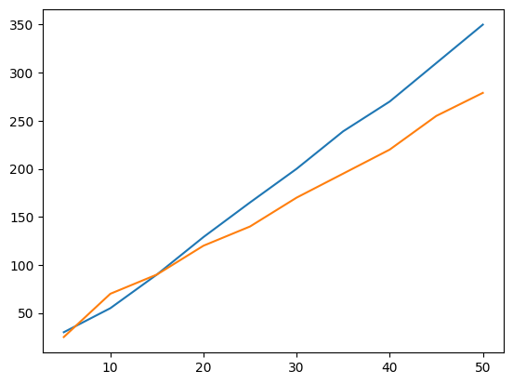
/tmp/ipykernel_1401/506286342.py:11: UserWarning: No artists with labels found to put in legend. Note that artists whose label start with an underscore are ignored when legend() is called with no argument.
cricket.legend()
<matplotlib.legend.Legend at 0x78ab6ca151d0>
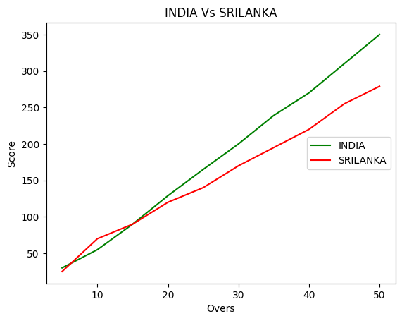
Exp No:3.b Conduct an experiment to show data visualization using bar chart
Code:
import matplotlib.pyplot as hscmark
import numpy as np
Names = ['SHREE', 'DEV', 'KEERTHI', 'PRIYA', 'SHAN', 'KUMARAN']
xaxis = np.arange(len(Names))
Percentage_hsc = [96, 91, 94, 75, 45, 81]
hscmark.bar(Names, Percentage_hsc)
hscmark.xticks(xaxis, Names, rotation=45)
hscmark.xlabel("Names of Pupil")
hscmark.ylabel("Percentage")
hscmark.title("Comparison of HSC Percentage", fontsize=20, color="green")
hscmark.show()
output:
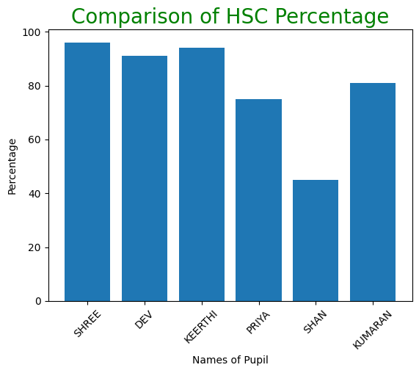
Exp No:3.c Conduct an experiment to show data visualization using pie chart
Code:
import matplotlib.pyplot as election
# Election data
labels = ['CANDIDATE 1', 'CANDIDATE 2', 'CANDIDATE 3', 'CANDIDATE 4']
Votes = [315, 130, 245, 210]
colors = ['green', 'yellow', 'red', 'orange']
explode = (0.2, 0, 0, 0)
# Plotting the pie chart
election.pie(Votes, labels=labels, colors=colors, explode=explode, autopct='%0.2f%%')
election.title('Election Results')
election.show()
output:
